**stress detection in IT professional by image processing**

**ABSTRACT:-**

The main conception of this paper is to descry stress in the IT professionals with the help of Deep literacy and Image processing ways. This paper is an upgraded interpretation of the old stress discovery systems which barred the live discovery and the particular comforting but this paper comprises of live discovery and periodic analysis of workers and detecting physical as well as internal stress situations in his/ her by furnishing them with proper remedies for managing stress by furnishing check form periodically. This paper substantially focuses on managing stress and making the working terrain healthy and robotic for the workers and to get the stylish out of them during working hours.in this when we detected different type behaviors of human being the person is in abnormal behavior like stress mood then we can control the person with smooth music.

# 1. INTRODUCTION:-

With the advent of modern technology our desires went high and it binds no bounds. In the present era a huge research work is going on in the field of digital image and image processing. The way of progression has been exponential and it is ever increasing. Image Processing is a vast area of research in present day world and its applications are very widespread. Image processing is the field of signal processing where both the input and output signals are images. One of the most important applications of Image processing is Facial expression recognition. Our person behavior is revealed by the expressions in our face. Facial Expressions plays an important role in interpersonal communication. Facial expression is a non verbal scientific gesture which gets expressed in our face based as per our person behaviors. Automatic recognition of facial expression plays an important role in artificial intelligence and robotics and thus it is a need of the generation. Some application related to this includes Personal identification and Access control, Videophone and Teleconferencing, Forensic application, Human-Computer Interaction, Automated Surveillance, Cosmetology and so on. The objective of this project is to develop Automatic Facial Expression Recognition System which can take human facial images containing some expression as input and recognize and classify it into seven different expression class such as :

**1.1. AIM:-**

The aim of the project is to detect the faces and get person behaviors from the human beings using video streaming. Using this we can identify the person behaviors with the file supporting to detect stress.

## 1.2O.BJECTIVE:-

The overall objective is to develop an automated Face based Person behaviors system for detecting stress comprising of a desktop application working in conjunction with deep learning.

**EXISTING METHOD:-**

The study of face based and its features is an active research area from past few decades. Pose variation, illumination conditions, bad lighting etc., are still challenging factors faced by all algorithms. Face based recognition and person behavior detection system are the major applications of recognition system, in which many algorithms have tried to solve these problems.

**Haar cascade files**

* Real time video streaming
* Classification accuracy is maximum

**Proposed method:**

* Pre-process
* Deep learning
* Human Behavior model
* Feature extraction

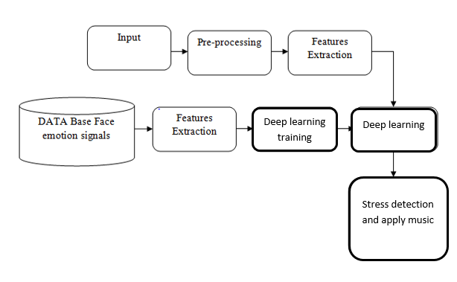

**Modules:**

**Ø Input image aciquisition**

**Ø Preprocess**

**Ø Feature extraction**

**Ø CNN**

**Modules Explanation:**

**Image acquisition:**

Image acquisition is achieved by suitable cameras. - Now the incoming energy is transformed into a voltage by the combination of input electrical power and sensor material of the camera. Image Acquisition using Single Sensor: An Example of a single sensor is a photodiode.

**Pre-process:**

Image stitching method involves steps such as feature detection and description, feature matching and homography estimation which are referred as preprocessing techniques. After this, postprocessing techniques like finalization of reference frame, image blending and compositing methods are studied.

Feature extraction: Feature extraction helps to reduce the amount of redundant data from the data set. In the end, the reduction of the data helps to build the model with less machine effort and also increases the speed of learning and generalization steps in the machine learning process.

**CNN:**

A Convolutional Neural Network (ConvNet/CNN) is a Deep Learning algorithm that can take in an input image, assign importance (learnable weights and biases) to various aspects/objects in the image, and be able to differentiate one from the other.

**Advantages:**

* Can relief the people from abnormal situations
* More accurate results
* Training of features are easy

* **Applications:**
* Entertainment applications
* Business applications

**Software requirements:**

* **Python idle**
* **Open-cv**
* **Tensor flow**
* **keras**

**Hardware requirements:**

* **WINDOWS 10 OS PC 64 BIT**
* **MINIMUM 4GB RAM**

**References: -**

[1] H. L. Wagner, R. Buck, M. Winterbotham, "Communication of specific person behaviors: Gender differences in sending accuracy and communication measures," J. Nonverbal. Behav., vol.17, pp.29-52, 1993.

[2] J. G. Allen, D. M. Haccoun, "Sex differences in person behaviorality: A multidimensional approach," Hum. Relat., vol. 29, pp. 711- 722, 1976.

[3] C. L. Barr, R. E. Kleck, Self-other perception of the intensity of facial expressions of person behavior: Do we know what we show," J. Pers. Soc. Psychol.vol. 68, pp.608-618, 1995.

[4] A. M. Kring, A. H. Gordon, "Sex differences in person behavior: Expression, experience, and physiology," J. Pers. Soc. Psychol. vol. 74, pp. 686-703, 1998.

[5] L. R. Brody, Gender, person behavioral expression, and parent-child boundaries. In R. D. Kavanaugh, B. Zimmerberg, & S. Fein (Eds.), Person behavior: Interdisciplinary perspectives, 1996, pp. 139-170. Mahwah, NJ: Lawrence Erlbaum.

[6] A. Campbell, "Staying alive: Evolution, culture and intra-female aggression," Behav. Brain. Sci., vol. 22, pp. 203-252, 1999.

[7] C. Kirschbaum, D. H. Hellhammer, "Salivary cortisol in psychoneuroendocrine research: Recent developments and applications." psychoneuroendocrino, vol.19, pp. 313–333, 1994.

[8] O. Houstis, S. Kiliaridis, "Gender and age differences in facial expressions," Eur. J. Orthod., vol. 31(5), pp. 459-466, 2009.